**ACTIVITY BASED ASSESSMENT**

COURSE NAME: AUTOMATA THEORY

COURSE CODE: 21IS54

Report on

# “TURING MACHINE CONSTRUCTION ”

Submitted by

S Meghana Reddy [4VV21IS087]

Tulsi S [4VV21IS110]

**INTRODUCTION:**

Automata theory, a cornerstone of computer science, provides a theoretical framework for understanding the capabilities and limitations of computational systems. At its core lies the study of abstract mathematical models of computation, which serve as powerful tools for analyzing algorithms, formal languages, and computational complexity. Among these models, the Turing machine stands as one of the most fundamental and influential.

Conceived by Alan Turing in the 1930s, the Turing machine represents a hypothetical device capable of simulating any algorithmic process. It consists of a finite set of states, a tape divided into discrete cells, a read/write head, and a transition function that dictates the machine's behavior based on its current state and the symbol read from the tape. Despite its simplicity, the Turing machine embodies the essence of computation, providing a formalism to explore the boundaries of what is computationally feasible and what is not.

In our project, we delve into the realm of automata theory with a specific focus on Turing machines. Our goal is to construct Turing machines using JFLAP, a versatile software tool renowned for its capabilities in designing, simulating, and analyzing various types of automata. By leveraging JFLAP's intuitive graphical interface and powerful simulation features, we aim to gain hands-on experience in constructing and analyzing Turing machines.

Central to our endeavor is the exploration of Turing machines as computational devices capable of solving a wide range of problems. Through the design and implementation of Turing machines within JFLAP, we seek to elucidate their computational power and understand the principles that underlie their operation. From simple tasks such as language recognition to more complex computations like simulating other computational models, our project aims to showcase the versatility and universality of Turing machines as computational engines.

In summary, our project represents a journey into the heart of automata theory, where we explore the power and potential of Turing machines using the versatile toolset provided by JFLAP. Through this exploration, we aim to gain insights into the nature of computation, expand our problem-solving capabilities, and appreciate the timeless significance of Turing machines in shaping the landscape of computer science.

# Turing Machine for a^n b^n

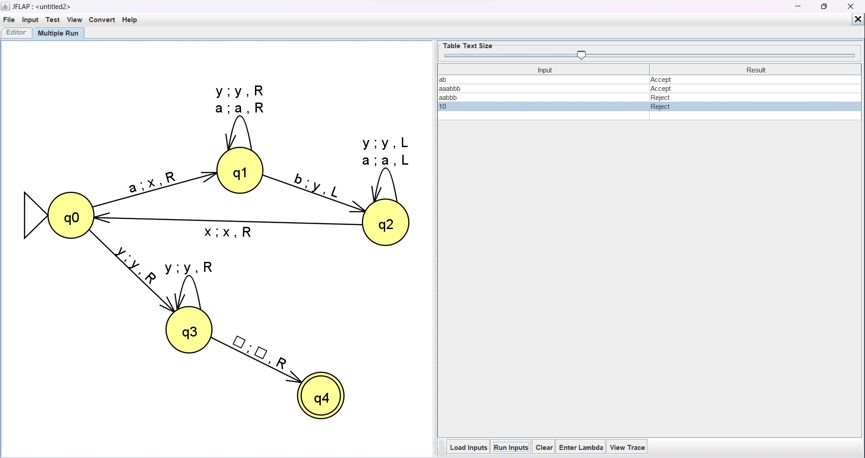

**Example :**

|  |  |  |  |  |  |  |
| --- | --- | --- | --- | --- | --- | --- |
| **a** | a | a | b | b | b | B |
| **x** | a | a | **b** | b | b | B |
| x | **a** | a | **y** | b | b | B |
| x | **x** | a | y | **b** | b | B |
| x | x | **a** | y | **y** | b | B |
| x | x | **x** | y | y | **b** | B |
| x | x | x | y | y | **y** | B |

# Turing Machine for both even and odd palindrome

**Example For Even Palindrome:**

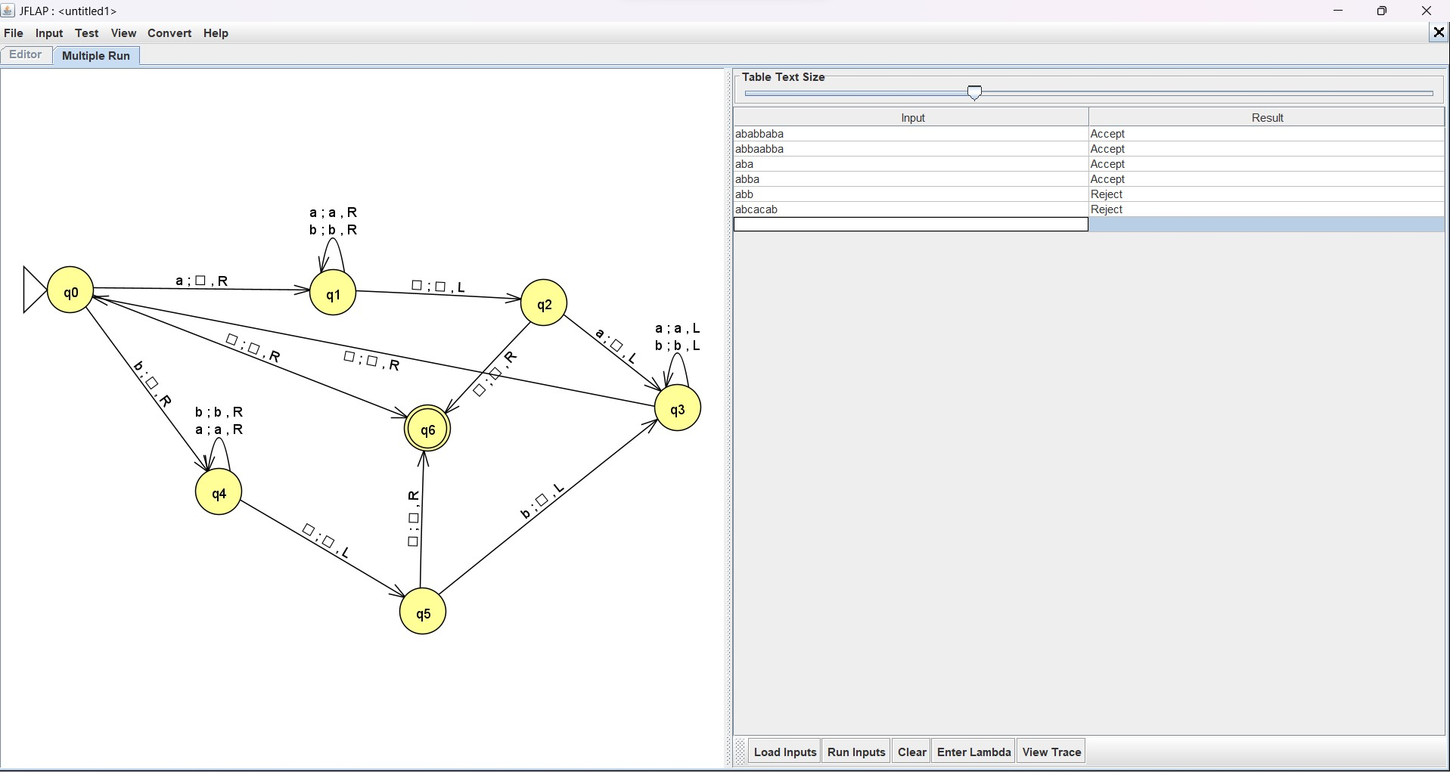

|  |  |  |  |  |  |  |  |  |
| --- | --- | --- | --- | --- | --- | --- | --- | --- |
| **a** | b | a | b | b | a | b | a | B |
| B | b | a | b | b | a | b | **a** | B |
| B | **b** | a | b | b | a | b | B | B |
| B | B | a | b | b | a | **b** | B | B |
| B | B | **a** | b | b | a | B | B | B |
| B | B | B | b | b | **a** | B | B | B |

|  |  |  |  |  |  |  |  |  |
| --- | --- | --- | --- | --- | --- | --- | --- | --- |
| B | B | B | **b** | b | B | B | B | B |
| B | B | B | B | **b** | B | B | B | B |
| B | B | B | B | B | B | B | B | B |

**Example For odd Palindrome:**

|  |  |  |  |  |  |  |  |  |  |
| --- | --- | --- | --- | --- | --- | --- | --- | --- | --- |
| **a** | b | a | b | c | b | a | b | a | B |
| B | b | a | b | c | b | a | b | **a** | B |
| B | **b** | a | b | c | b | a | b | B | B |
| B | B | a | b | c | b | a | **b** | B | B |
| B | B | **a** | b | c | b | a | B | B | B |
| B | B | B | b | c | b | **a** | B | B | B |
| B | B | B | **b** | c | b | B | B | B | B |
| B | B | B | B | c | **b** | B | B | B | B |
| B | B | B | B | c | B | B | B | B | B |

# Turing machine for equal number of a’s and b’s

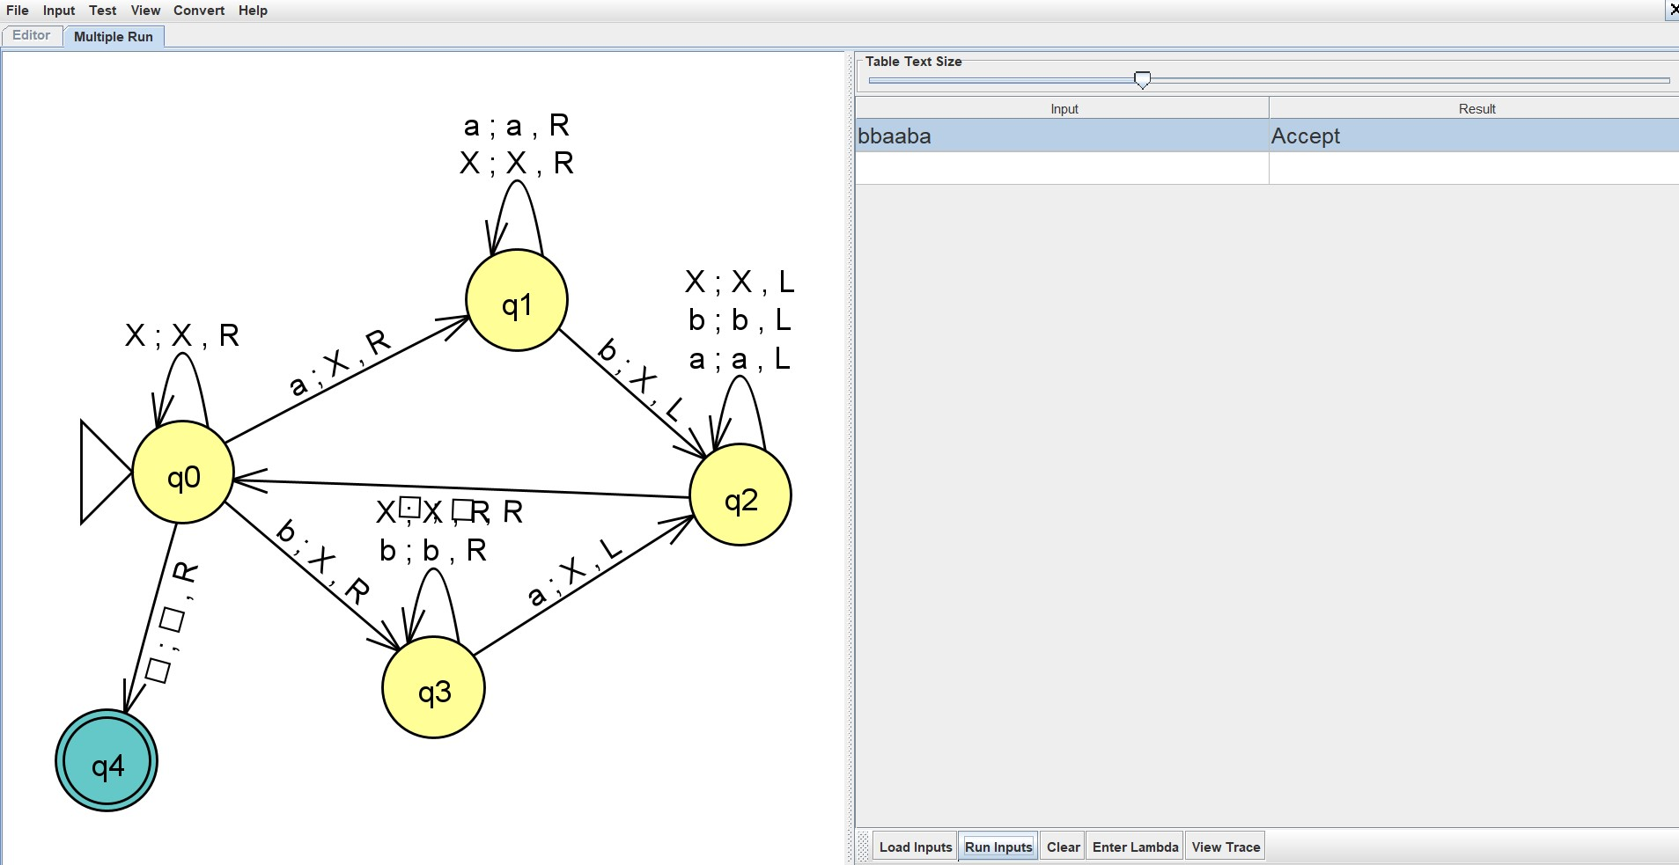

**Example:**

|  |  |  |  |  |  |  |  |
| --- | --- | --- | --- | --- | --- | --- | --- |
| B | b | b | **a** | a | b | a | B |
| B | **b** | b | **X** | a | b | a | B |
| B | **X** | b | X | **a** | b | a | B |
| B | X | **b** | X | **X** | b | a | B |
| B | X | **X** | X | X | b | **a** | B |
| B | X | X | X | X | **b** | **X** | B |
| B | X | X | X | X | **X** | X | B |

**CONCLUSION:**

In conclusion, our project embarked on the task of constructing Turing machines within the JFLAP software environment to address specific language recognition challenges. Through meticulous construction and simulation of Turing machines for various string languages, we rigorously evaluated their acceptance or rejection properties. This process not only deepened our comprehension of Turing machines' operational principles but also provided practical insights into their applicability in language recognition tasks.

Furthermore, by systematically analyzing the behavior of Turing machines designed for different string languages, we gained valuable insights into the nuances of computational linguistics. Our findings underscored the importance of algorithmic precision and computational complexity in effectively modeling language recognition processes. Moreover, our project showcased the utility of JFLAP as a versatile tool for visualizing and analyzing automata constructions, facilitating a seamless exploration of computational models and their applications.

Looking ahead, the outcomes of our project lay the groundwork for further exploration into language recognition algorithms and computational linguistics. By refining and expanding our repertoire of Turing machine constructions within JFLAP, we aim to delve deeper into the complexities of language recognition and computational grammar. Ultimately, our project contributes to the broader goal of advancing automata theory and its practical implications in language processing, paving the way for future innovations in computational linguistics and artificial intelligence.